# Assignment 7

# Use the data collected from two arrays (Target Array and Reference Array, totally 12 antenna elements) to detect the following information:

# 1. Detect the main angles of arrival (AoAs) of each antenna array. They may be line-of-sight or scattering path. Find the possible main scattering clusters according to Baidu map.

# 2. Direct the receiving beam to the running student, show the Doppler frequency of his scattering path and his position versus time.

# AOA数据使用说明

* 采样率：25MHz
* 中心频点：2.12GHz
* 数据总时长：0.5s
* Data_aoa.mat文件用MATLABA打开后如Fig. 1所示的一个矩阵。
* 数据前八行为target数据（如Fig.2 target天线对准人运动），后四行为Reference数据（如Fig.3 ref天线对准基站）。
* 每一行数据是一根天线0.5s内采到的数据。
* 数据采集地点：

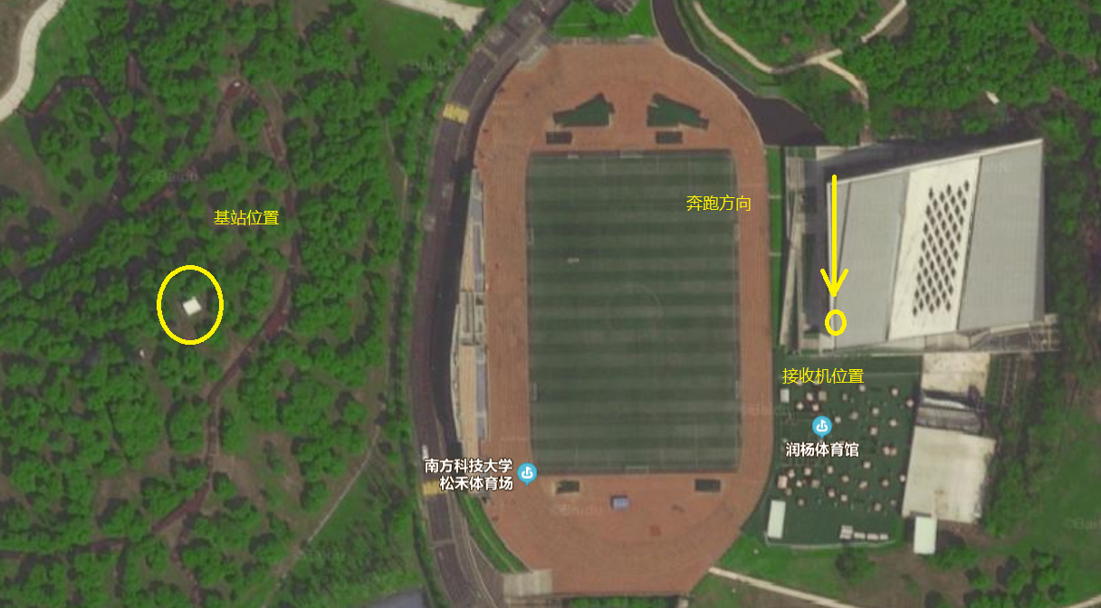

润扬体育馆三楼

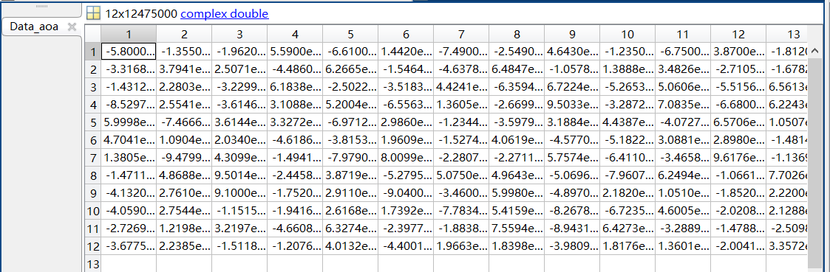

Fig.1 Data_AOA

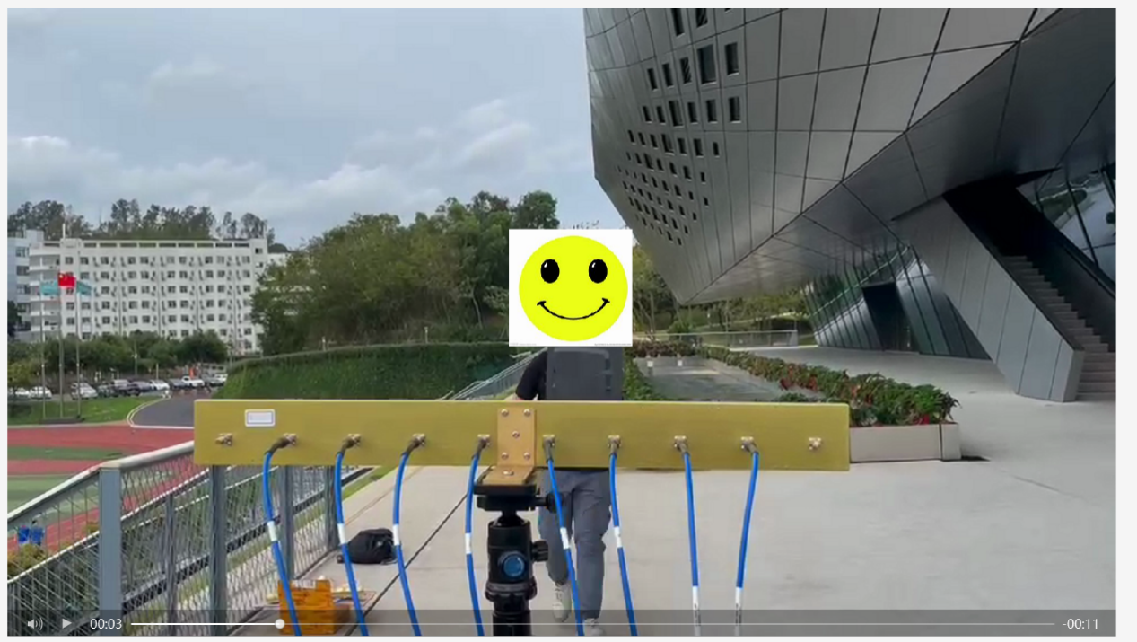

Fig.2 Target Array

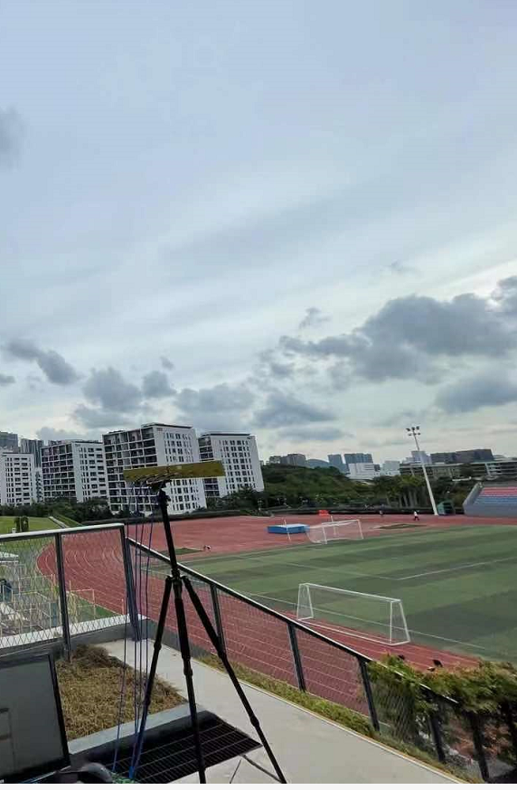

Figure 3 Reference Array

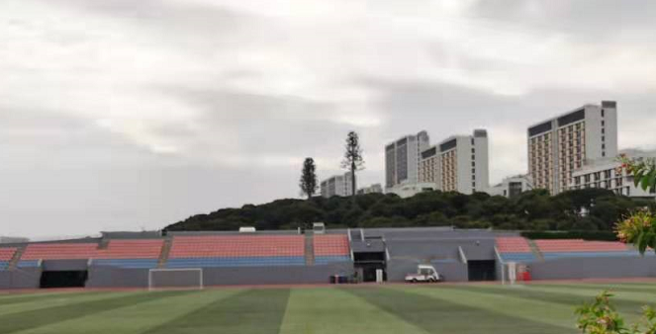

Figure 4 基站位置